
Agri-Tech Hackathon 2026
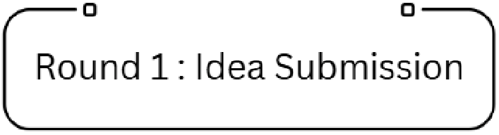

Team Name: TerraTech
Team Leader: Swastik Sonawane

Problem Statement:
Modern agriculture lacks integrated intelligence to correlate crop health, soil conditions, and environmental data in real time. Delayed disease detection and non-optimized pesticide and fertilizer application result in excessive chemical use and declining soil quality. This problem calls for an AI-driven, sensor-based farming system that continuously monitors soil health, detects crop diseases at an early stage, and provides actionable recommendations via an interactive real-time software platform to support sustainable and climate-resilient farming.

Problem Identified:
- Existing agricultural practices lack real-time intelligence to correlate soil conditions, crop health, and environmental factors.
- Disease detection is largely manual and reactive, allowing pests and infections to spread before corrective action is taken.
- Non-optimized pesticide and fertilizer application leads to excessive chemical usage and long-term soil degradation.
- Farmers do not have access to unified, interactive software platforms that translate sensor and vision data into clear, actionable recommendations

Describe your solution:

- Basic diagram of our idea
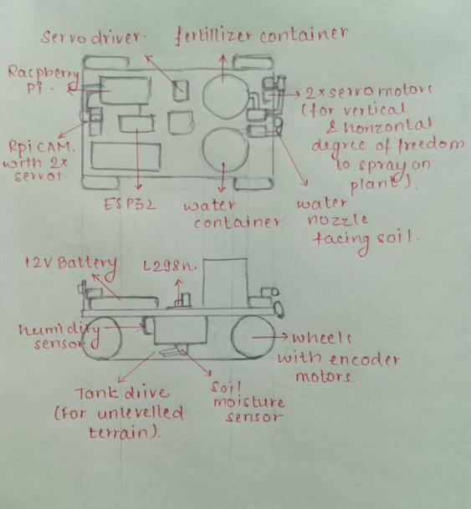

The proposed solution is an AI-enabled, IoT-based smart agriculture system aimed at promoting sustainable and climate-resilient farming practices. A Raspberry Pi equipped with a camera captures real-time images of crops, which are analyzed using a YOLO-based deep learning model trained on the PlantVillage dataset to enable early detection of pests and diseases. The model identifies the disease type along with its severity level, allowing timely and targeted intervention.

To monitor field conditions, the system continuously measures soil moisture, temperature, humidity, and pH using sensors deployed in the soil. These parameters are analyzed to assess overall soil health, determine environmental conditions, and estimate crop water requirements, thereby reducing over-irrigation and resource wastage.

Based on inputs from disease detection, soil health analysis, and farmer-selected information such as crop type and growth stage, the system generates intelligent recommendations for pesticide and fertilizer application. A controlled spraying mechanism ensures that agrochemicals are applied only when required and in appropriate quantities, minimizing excessive chemical usage and environmental impact.

All processed information and recommendations are delivered through a real-time interactive software interface that displays live soil health status, disease alerts, weather insights obtained via a weather API, and optimized suggestions for pesticide, fertilizer, and irrigation management. The solution is demonstrated using a four-wheel tank mobile prototype with an adjustable camera mount and a targeted spraying mechanism, showcasing a practical and scalable approach to smart agriculture.
The novelty of the proposed system lies in its integrated approach that combines vision-based disease detection, real-time soil health monitoring, and intelligent agro-input recommendations within a single platform. Unlike traditional systems that operate in isolation, this solution correlates crop health, soil conditions, and environmental data to support precise and sustainable farming decisions.

Technology Stack:
Hardware & Mechanical System:
- Raspberry Pi
- Raspberry Pi Camera Module
- Soil moisture sensor
- CO2 sensor
- Temperature and humidity sensor (DHT22)
- Soil nutrient sensor
- pH sensor
- Micro pump and spray nozzle
- ESP-32
- Servo motors & Servo Driver
- DC Encoder motor & L298N Motor Driver
Artificial Intelligence & Image Processing:
- Python
- OpenCV
- YOLO (You Only Look Once) deep learning model
- PlantVillage dataset for pest and disease detection
Software & Interface:
- Python for backend data transmission to ESP32
- App development using flutter for real time data report and manual control intervention if required
- App data will be received by ESP via Wifi/Bluetooth communication.
Development Tools:
- Raspberry Pi OS
- VS Code (Python)
- Arduino IDE
- Git (For version control)

Use Case Diagram/Flow Diagram:
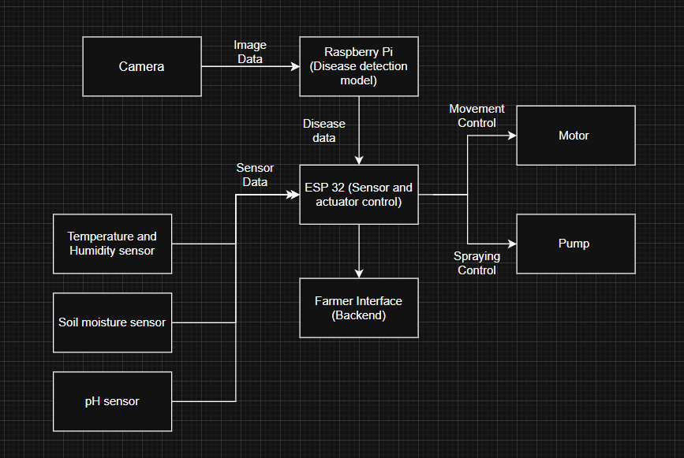

The block diagram shows a modular smart agriculture system where crop images are processed by a Raspberry Pi for disease detection, while soil and environmental data are collected by sensors and handled by an ESP32. The ESP32 controls movement and spraying actions and forwards all relevant data to the farmer interface backend for real-time monitoring and decision support.

Overall working of this robot :
The ESP32 microcontroller serves as the central control unit of the system, interfacing with multiple sensors and a Raspberry Pi. The Raspberry Pi performs plant disease detection using image analysis and processes quantitative health parameters for each plant. This processed data is transmitted to the ESP32 via ROS-based communication.

A comprehensive analysis report, including the current crop condition and recommended corrective actions, is generated and sent to the farmer’s mobile application. The mobile application also includes a robot control interface, which is used initially to map the entire farm. This stored map enables the robot to autonomously replicate the same inspection path in future operations, with provisions to modify the path if farm conditions change.

After completing farm-wide analysis and reporting, the farmer supplies the recommended fertilizer into an onboard container. During a second operational pass, the robot sprays the fertilizer as prescribed. Additionally, soil moisture data is used to regulate water spraying, ensuring optimal moisture levels are maintained at the plant roots.

